**Compile Instructions to run the program and test**

* Unzip the folder NLP_Project
* 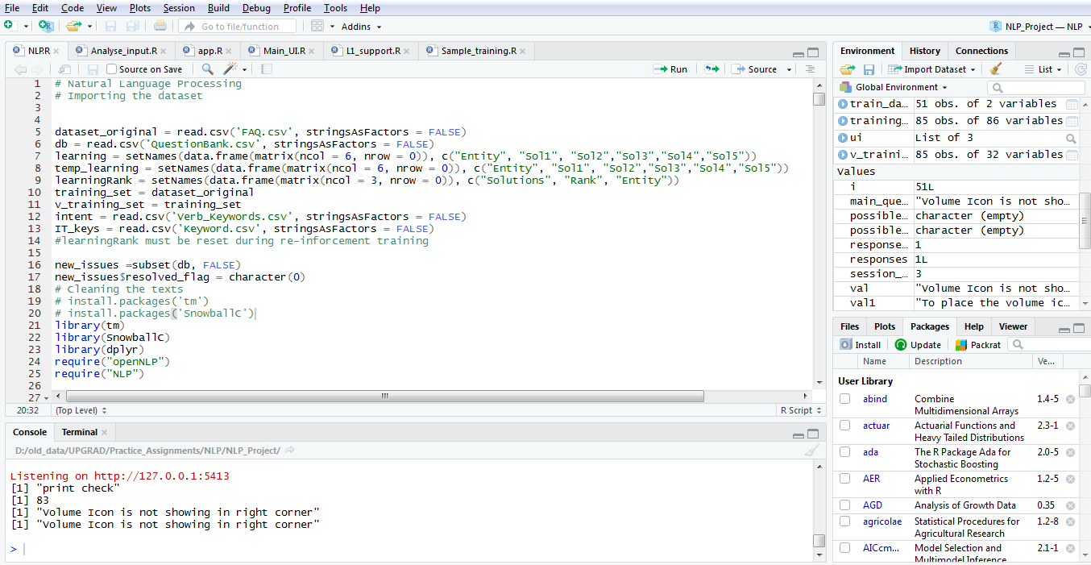Open the R project file NLP_Project
* It will open up this window.
* Load all the 6 .R files.
  + NLP.R
  + Analyse_input.R
  + App.R
  + Main_UI.R
  + L1_support.R
  + Sample_training.R
* Select the full file NLP.R and press ctrl+enter to execute
  + If you face any error , please install all the required packages.
* Select the full file Analyse_input.R and press ctrl+enter to execute.
* Select the full file App.R except the last line and press ctrl+enter to execute

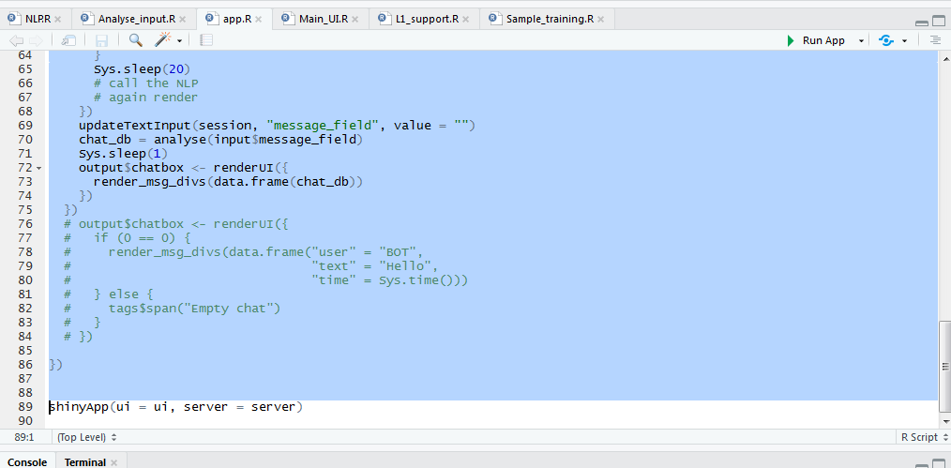

* Select the full file Main_UI.R and press ctrl+enter to execute.
* Select Train Model for first time training
* 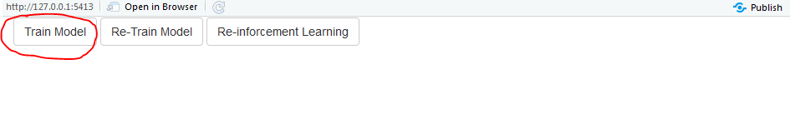
* In App.R file , select and execute the line 89: shinyApp(ui = ui, server = server)
* It will open up the chat window.
* Put your query and select the proper recommendation to view.
* In case there is no available solution, system will raise a ticket automatically.
* 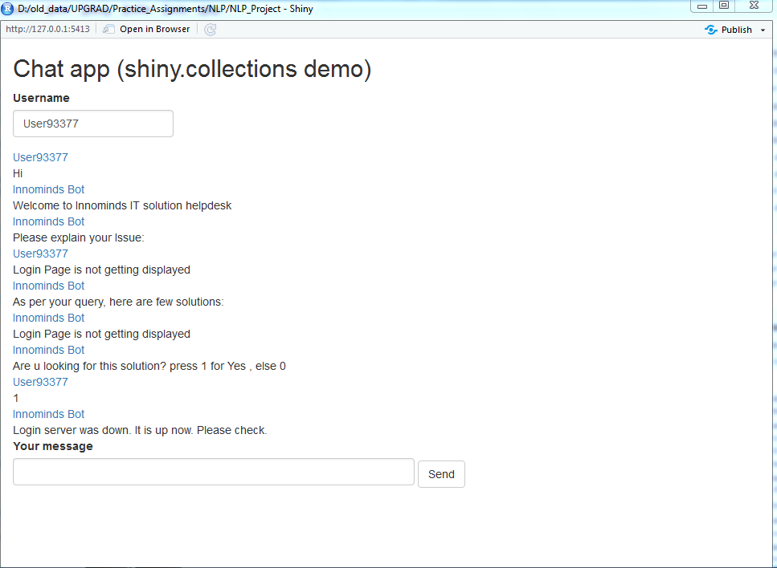
* To provide a manual solution as a L1 agent, select and execute L1_support.R file.
* 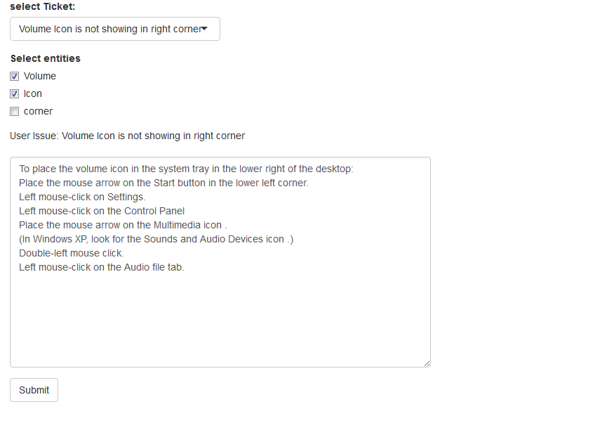
* To re train the model on new solutions, select the full file Main_UI.R and press ctrl+enter to execute.
* Select Re-train Model
* 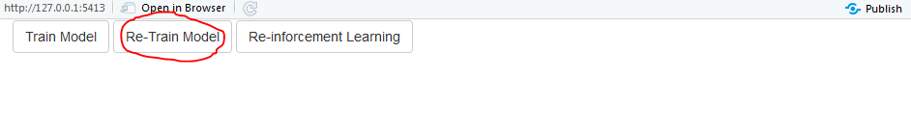
* To re train the model on new batch of questions with their solutions, select Sample_training.R file and execute the full file.
* Wait for the model to parse the new entities and intents.
* Re train the model by selecting Re-train Model on execution of Main_UI.R